LYON, January 10 2018

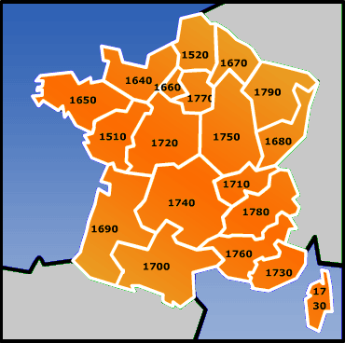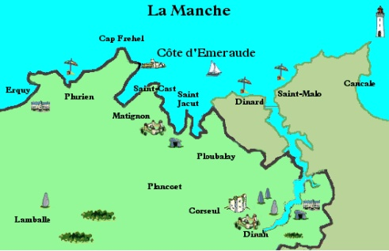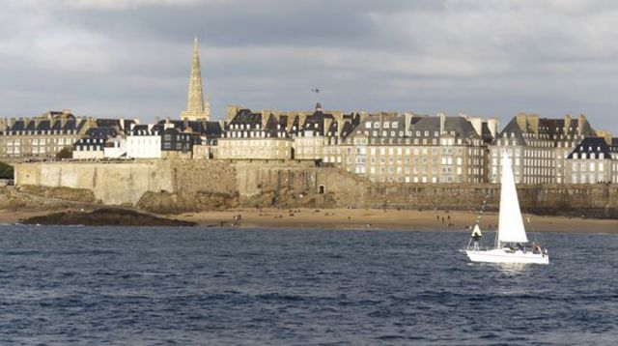

**" DISCOVERY of the EMERALD COAST "**

*Dates* **: Sunday 1st to Thursday 12th JULY 2018**

*Host Clubs* : **SAINT MALO/DINARD/ JACQUES CARTIER + DINARD COTE D’EMERAUDE Rotary****Clubs**

**DISTRICT 1650**

*Participants* : **15 / 1 BOY or 1 GIRL from your country / 14 - 18 years**  **old** at the beginning of the camp

*Program* : Cultural visits, water sports, cooking, leisure activities… while sharing friendship …A detailed program will be sent later by the Organizer

*Language* : **ENGLISH or/and FRENCH**

*Accommodation* : with families.

*Arrival and departure* : **RENNES airport or SAINT MALO station**

*Fees* : **200 euros /participant, to be paid before 1st JUNE**

*Insurance* : against illness, accident and third party damages ; participants will send the certificate to the Organizer before the arrival in France

*Application* : by email with all requested signatures to : [gisele.pont@crjfr.org](mailto:gisele.pont@crjfr.org) and [multidistrictfrance@crjfr.org](mailto:multidistrictfrance@crjfr.org)