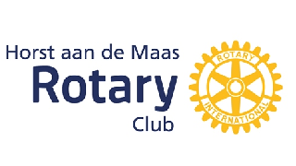

Camp NL2 The Netherlands
DISCOVER, UNITE and ENJOY
Monday July 9th - Friday July 20th

Organised by: Rotary Club Horst aan de Maas
Date: 9-20 July 2018
Participants: 10 males and 10 females
Age: 18-22 years
Costs: €200,-
Conditions: Maximum of 1 male and 1 female per country within EC or Schengen countries, outside EC one candidate per country.
Accommodation: 1 week with the host families and 1 midweek at a camp place
Point of arrival: Eindhoven Airport
Düsseldorf Airport
Horst train station
Venlo train station
Insurance: Participants must have Travel and Health insurance eligible for the
Netherlands

Welcome to our summer camp. Who are we? We are a group of young people between 18-22 years old, who are working together with the Rotary Club of Horst aan de Maas. In July 2018 we will organise a summer camp based on discovering, uniting and enjoying the Netherlands. What will you be doing at this camp? Everyday there will be organised exciting activities, were you really need to work together. We will visit Amsterdam and Maastricht, have more in-depth conversations with each other, visit a professional soccer club and the local soccer club (don’t forget a sporty outfit) , cycle around the area, debate about our cultures, sit around the bonfire, have active activities and a breakfast competition with some Dutch goodies. You will be spending one week with your host family and one midweek at a local camping place. We are looking forward to the camp and hope to see you there!

